- Tên và phân loại:

- Mục đích, ý nghĩa:
- Avoid coupling the sender of a request to its receiver by
giving more than one object a chance to handle the request
- Chain the receiving objects and pass the request along the
chain until an object handles it.
- Động lực sử dụng:
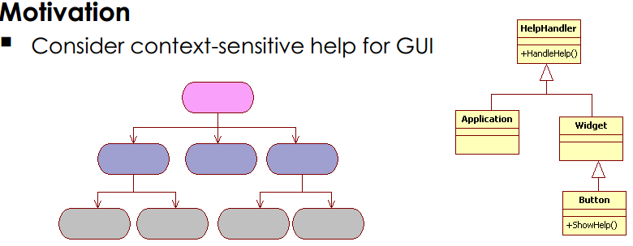
- Khi nào sử dụng:
- More than one object may handle a request, and the handler
isn't known a priori. The handler should be ascertained
automatically
- You want to issue a request to one of several objects without
specifying the receiver explicitly
- The set of objects that can handle a request should be
specified dynamically
- Cấu trúc
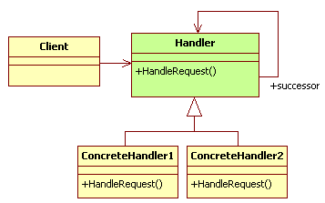
- Các thành viên - Sự cộng tác
- Handler
• Defines an interface for handling requests
• Implements the successor link (optional)
- ConcreteHandler
• Handles requests it is responsible for
• Can access its successor. If the ConcreteHandler can handle the request,
it does so; otherwise it forwards the request to its successor
- Client: initiates the request to a ConcreteHandler object on
the chain
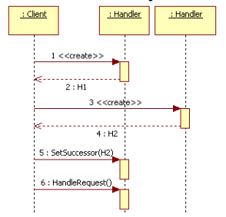
- Các hệ quả mang lại:
- Reduced coupling
• Frees an object from knowing which other object handles a
request. An object only has to know that a request will be
handled "appropriately“
• Both the receiver and the sender have no explicit knowledge of
each other, and an object in the chain doesn't have to know
about the chain's structure

- Added flexibility in assigning responsibilities to objects
• Gives you added flexibility in distributing responsibilities among
objects
- You can add or change responsibilities for handling a request by
adding to or otherwise changing the chain at run-time
- You can combine this with sub-classing to specialize handlers
statically

- Receipt isn't guaranteed
• Since a request has no explicit receiver, there's no guarantee it'll
be handled – the request can fall off the end of the chain without
ever being handled
• A request can also go unhandled when the chain is not
configured properly
- Chú ý liên quan đến cài đặt:

- Hệ thống thực tế

- Mẫu liên quan
- Chain of Responsibility is often applied in conjunction with
Composite

